Task on CloudFront & Route 53
- Configure VPC peering in cross regions.
Login to aws console.
Go to VPC service.
Click on create VPC give VPC name and CIDR range create VPC.
Create VPC on another region with the above steps.
Navigate to peering connection section.
Click on create peering connection.
Fill the below details
Name tag: us-east-1-to-eu-north-1.
Requester VPC ID: Select your VPC in us-east-1.
Accepter VPC ID: Enter the VPC ID from eu-north-1.
Accepter region: Choose eu-north-1.
Click on create peering connection.
Switch to the eu-north-1 VPC console.
Go to Peering Connections.
Locate the pending request and click Accept Request.
For both VPCs:
- Go to Route Tables.
- Add a route to the peer VPC’s CIDR block with the target = Peering Connection.
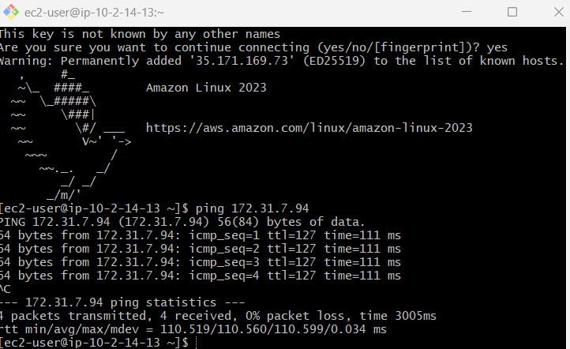
- Purchase one domain from GoDaddy.
Go to godaddy.com
Sign-in search for you domain buy the domain
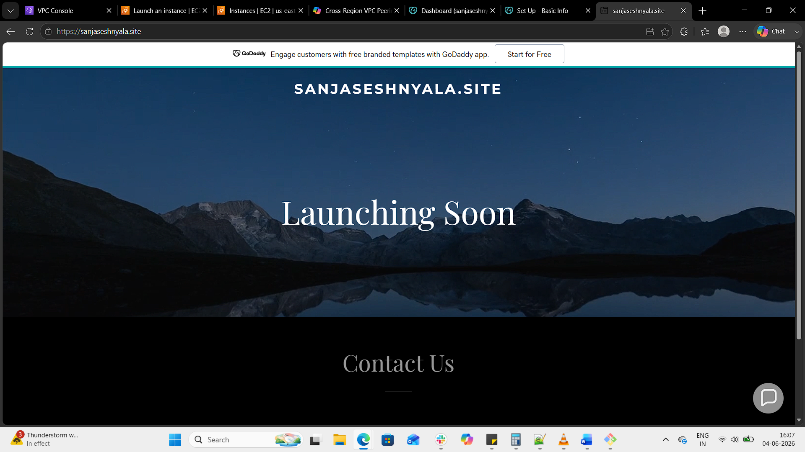
- Deploy static website in S3.
Step 1: Create an S3 Bucket
Go to the S3 Console.
Click Create bucket.
Enter a globally unique bucket name (e.g., sanjaseshnyala-site).
  - If you plan to use your domain, name it exactly as your domain (sanjaseshnyala.site).
Select a region (e.g., us-east-1).
Leave other defaults and click Create bucket.
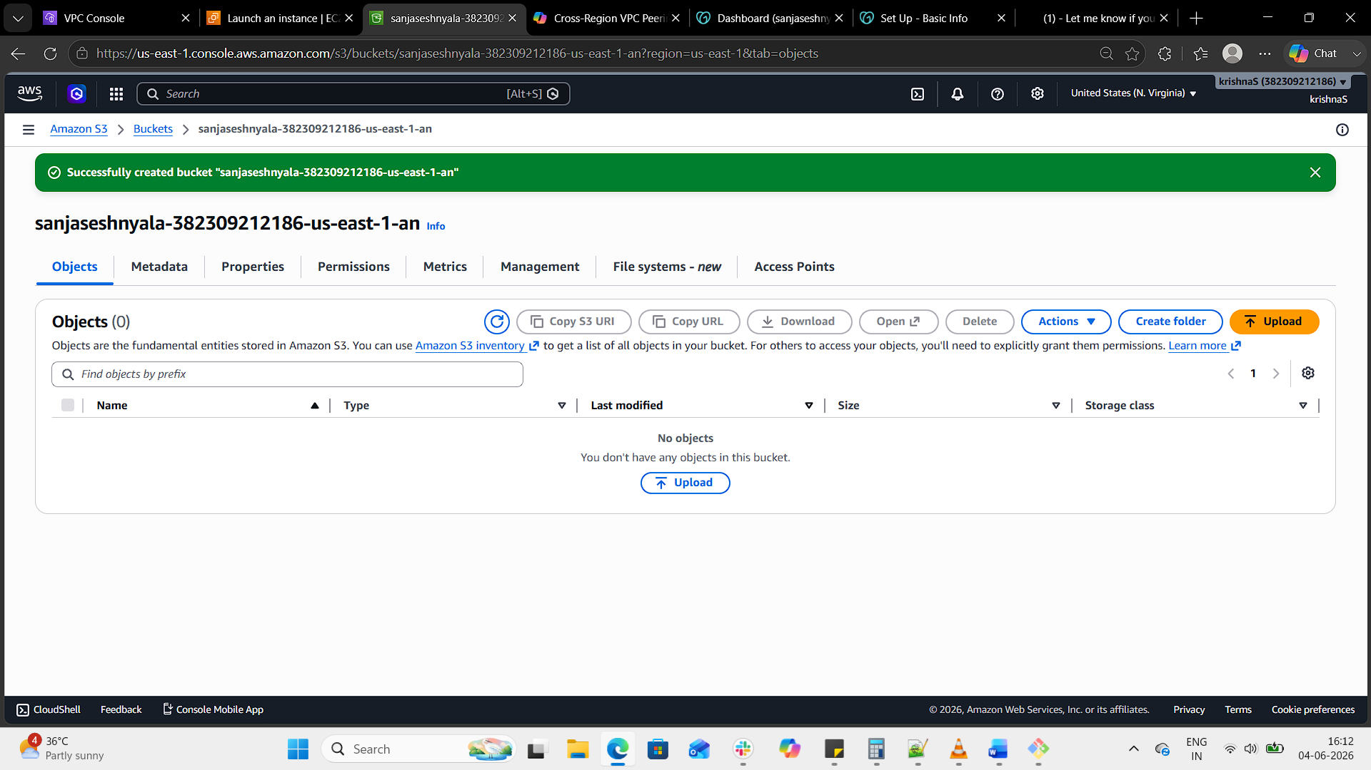
Step 2: Upload Website Files
Open your new bucket.
Go to the Objects tab.
Click Upload → Add files.
Upload your index.html, error.html, CSS, JS, and image files.
Click Upload.
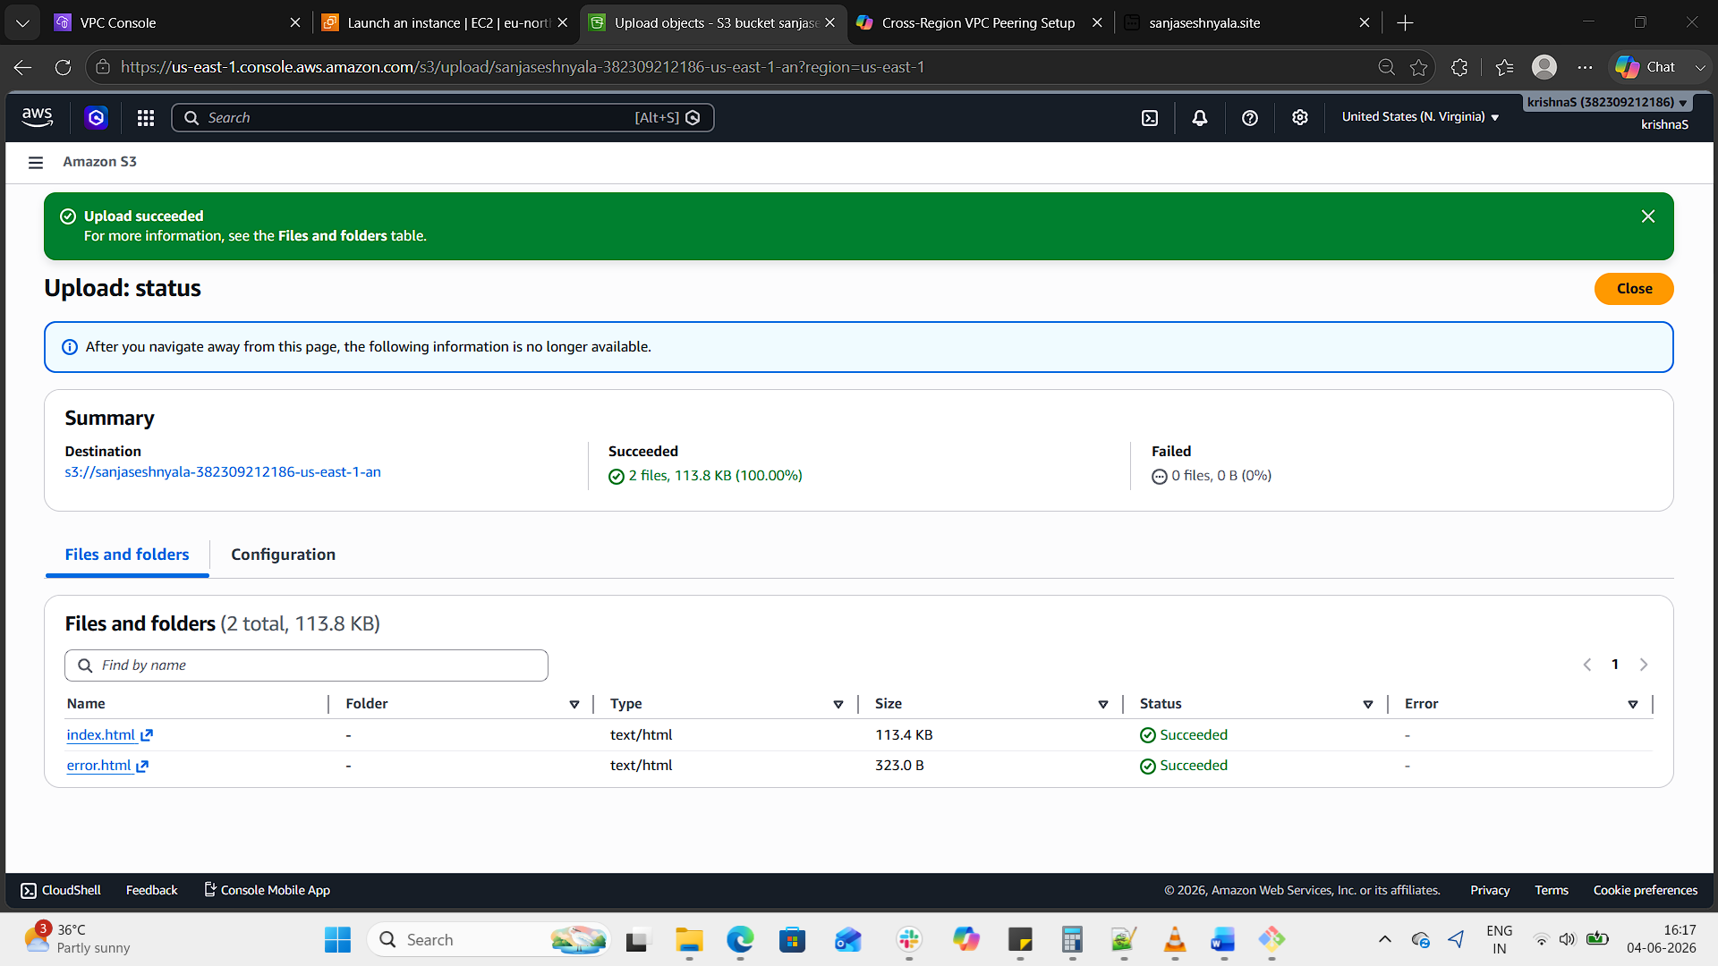
Step 3: Enable Static Website Hosting
In the bucket, go to the Properties tab.
Scroll down to Static website hosting.
Click Edit → Enable.
Enter:
  - Index document: index.html
  - Error document: error.html
Save changes.
AWS will give you a website endpoint URL (e.g., http://sanjaseshnyala-site.s3-website-us-east-1.amazonaws.com).
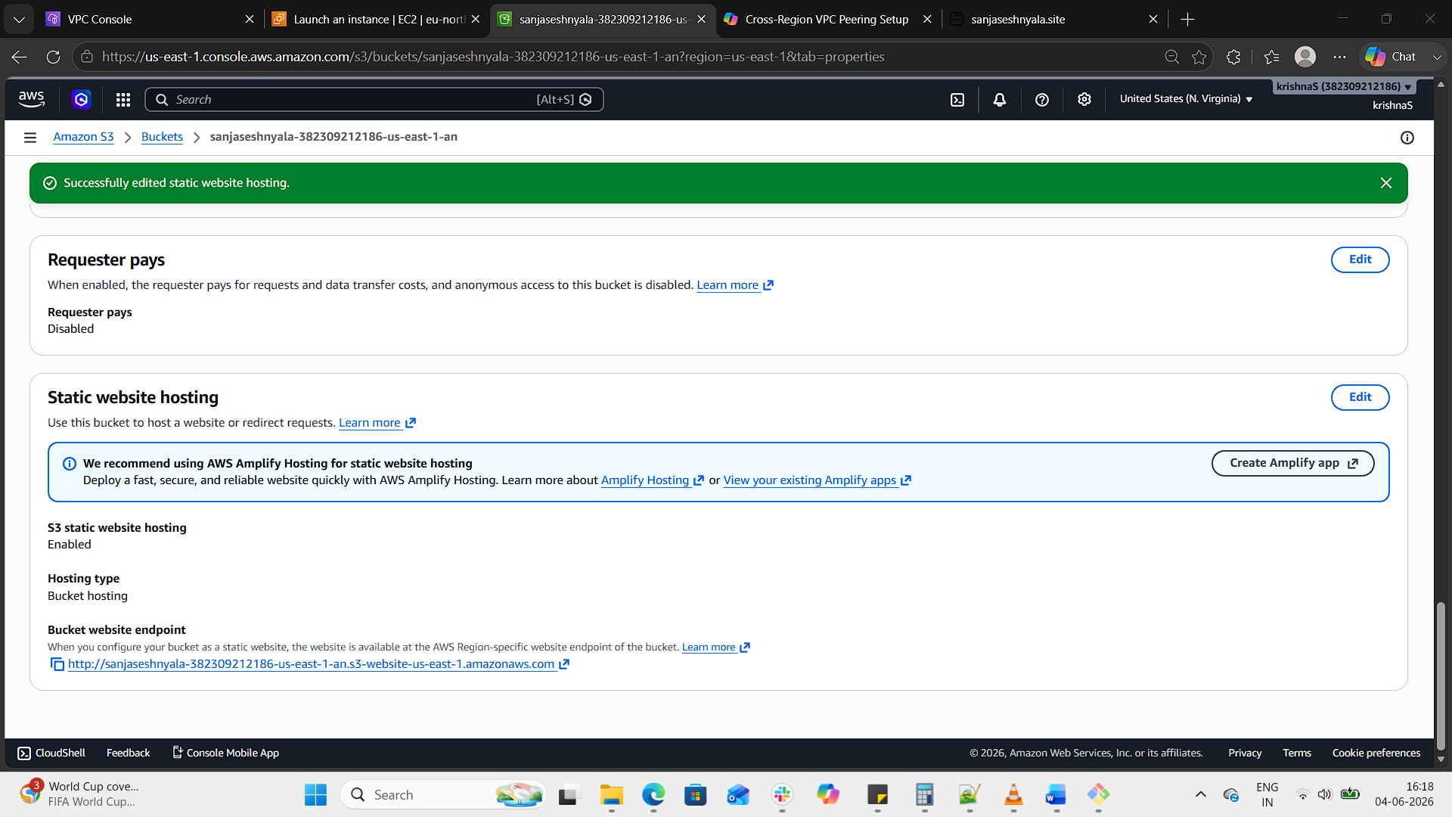
Step 4: Make Content Public
Go to the Permissions → Bucket policy.
Add a policy to allow public read access:
json
{
"Version":"2012-10-17",
"Statement":[
{
"Sid":"PublicReadGetObject",
"Effect":"Allow",
"Principal":"*",
"Action":["s3:GetObject"],
"Resource":["arn:aws:s3:::sanjaseshnyala-site/*"]
}
]
}
Save the policy.
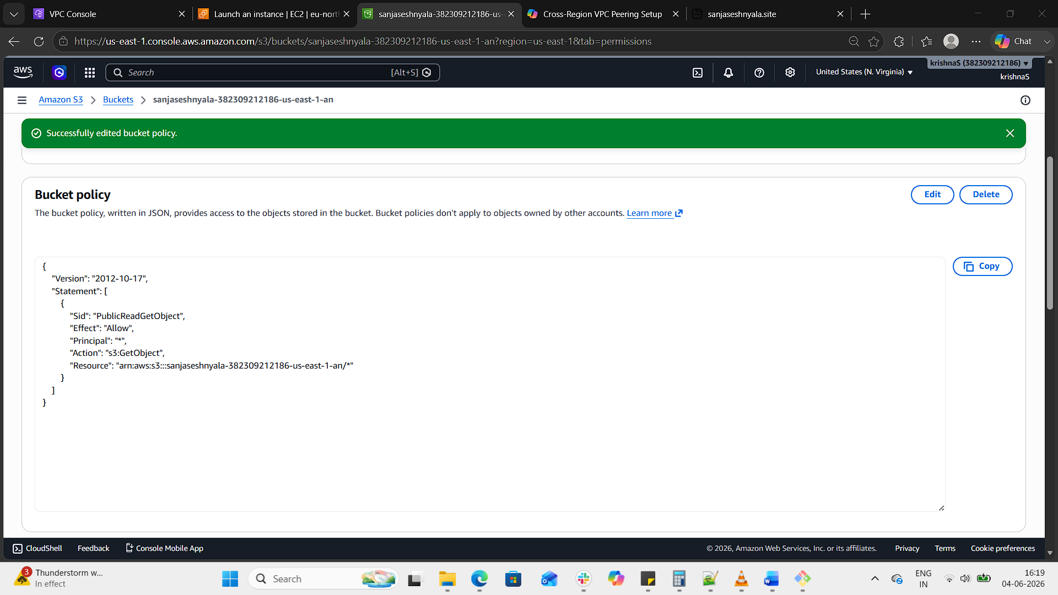
Step 5: Test Your Site
Open http://sanjaseshnyala.site or the S3 endpoint.
Your static site should load.
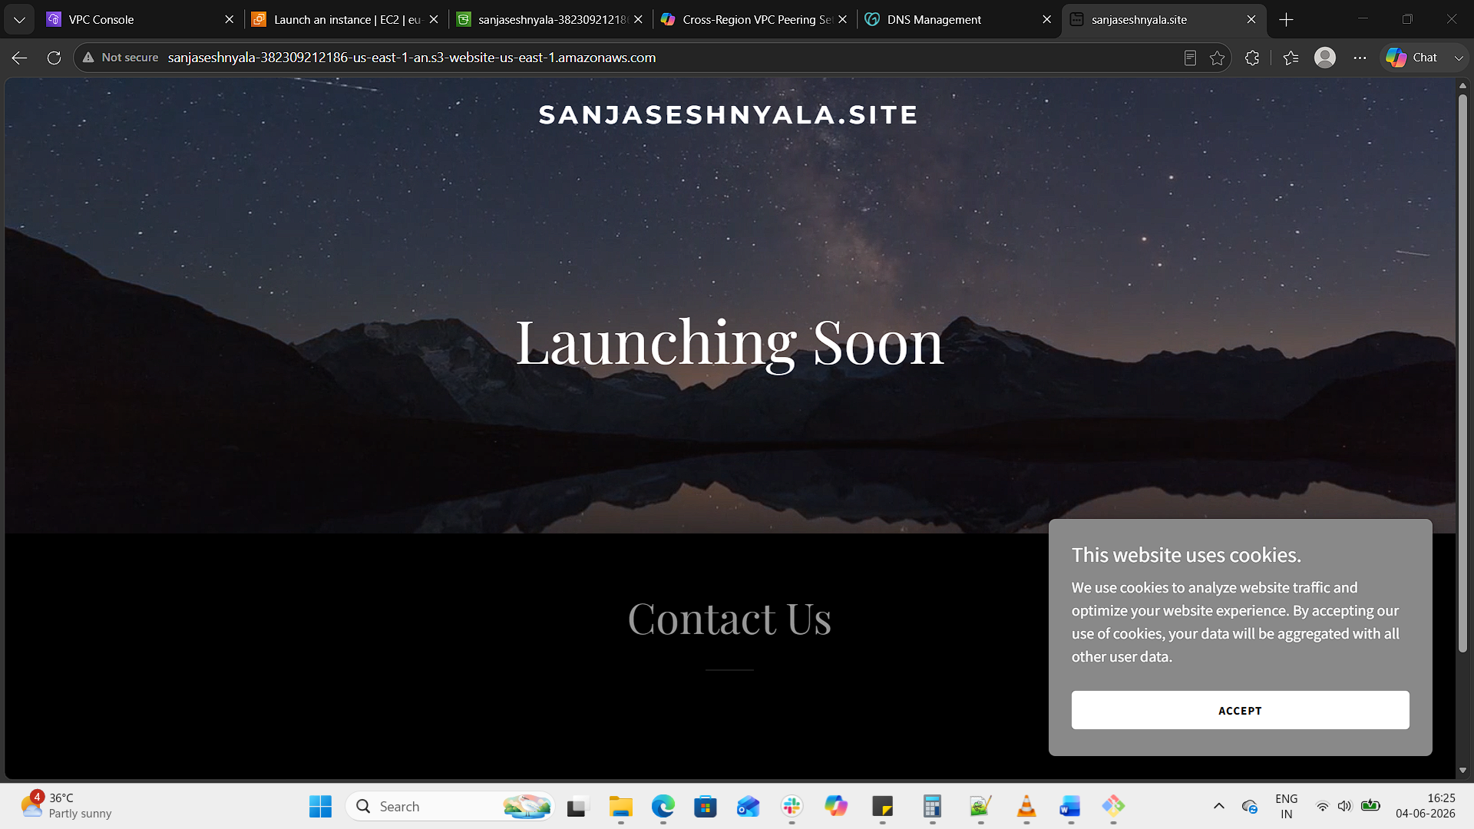
- Create a CDN and attach one SSL certificate.
Step 1: Request an SSL Certificate
Go to the AWS Certificate Manager (ACM) console.
Click Request a certificate → Request a public certificate.
Enter your domain name (e.g., sanjaseshnyala.site and optionally www.sanjaseshnyala.site).
Choose DNS validation (recommended).
ACM will give you a CNAME record to add in your GoDaddy DNS.
  - In your GoDaddy DNS tab, add the CNAME exactly as shown.
Once DNS propagates, the certificate status will change to Issued.
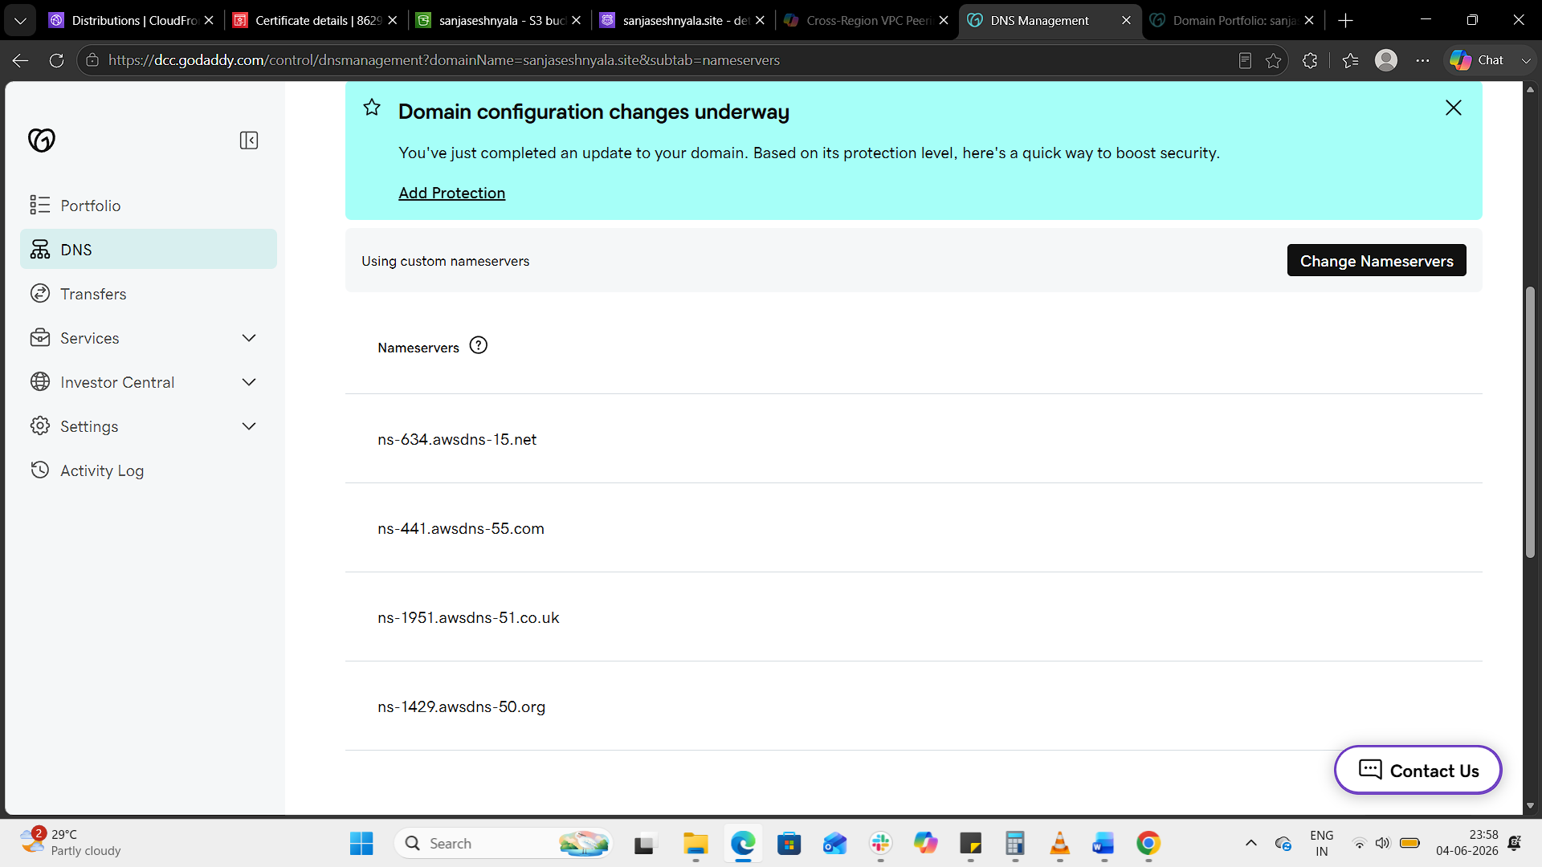
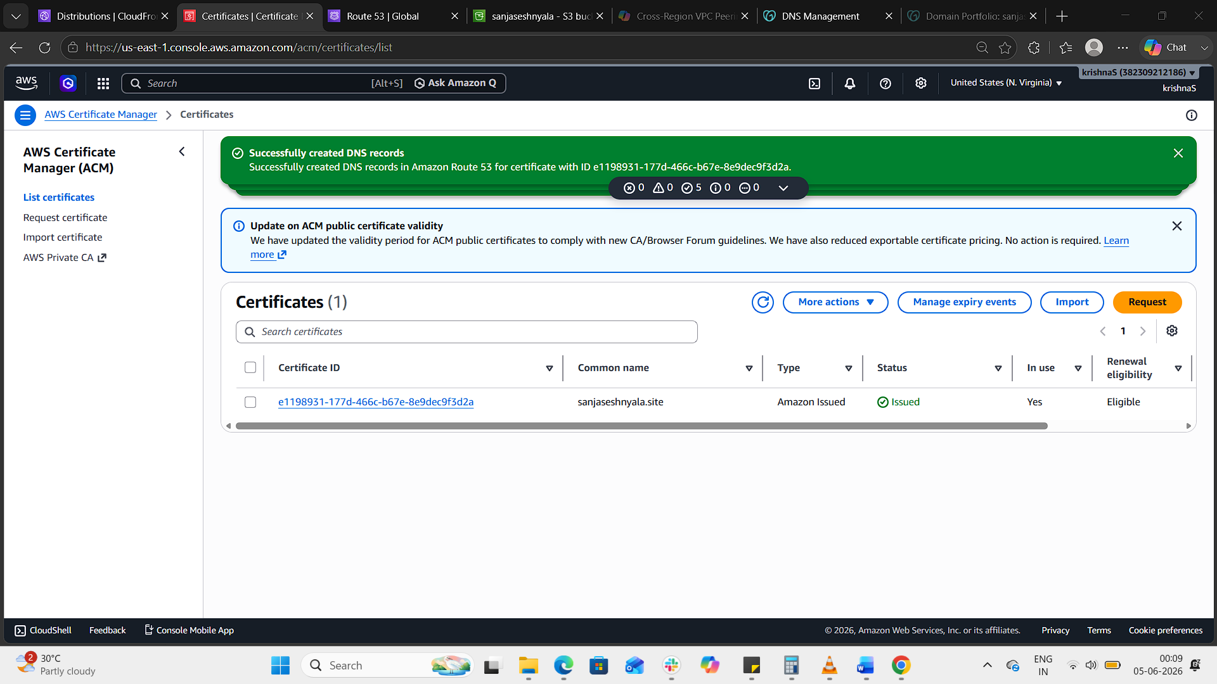
Step 2: Create a CloudFront Distribution
Go to the CloudFront console → Create distribution.
Under Origin settings:
  - Origin domain: Select your S3 bucket website endpoint (e.g., sanjaseshnyala-382309212186-us-east-1-an.s3-website-us-east-1.amazonaws.com).
  - Origin access: If you want private access, configure Origin Access Control (OAC), otherwise leave public.
Under Default cache behavior:
  - Viewer protocol policy: Redirect HTTP to HTTPS.
Under Settings:
  - Alternate domain names (CNAMEs): Add sanjaseshnyala.site and www.sanjaseshnyala.site.
  - SSL certificate: Select the ACM certificate you just created.
  - Default root object: index.html.
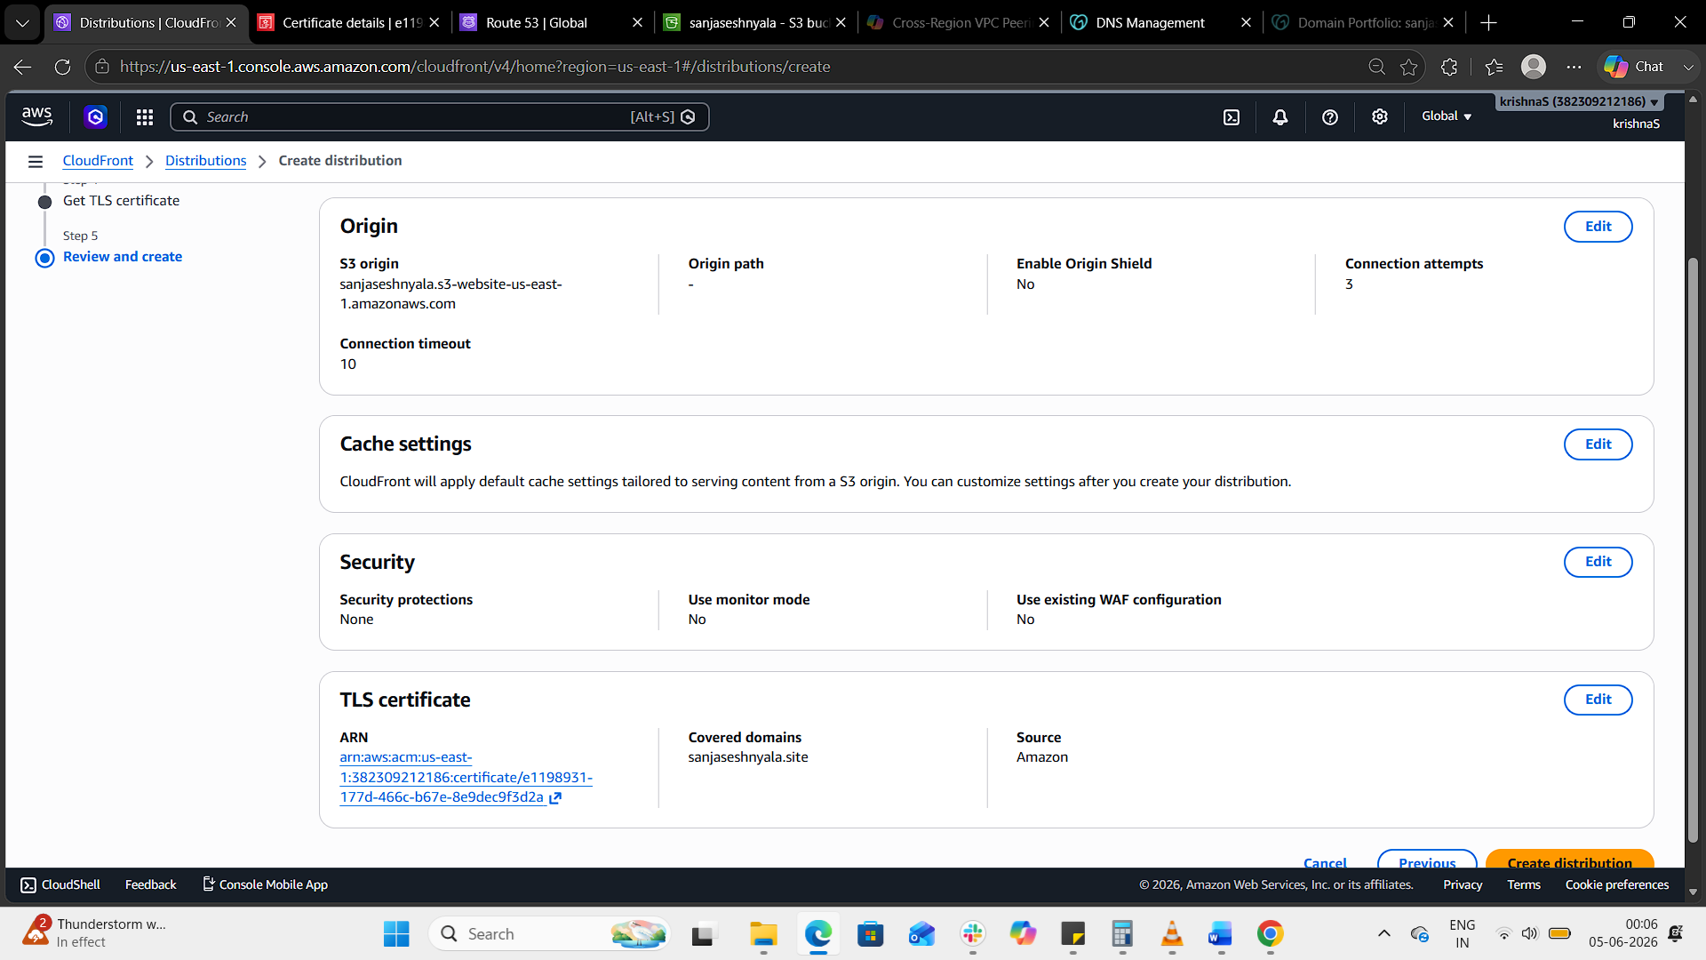

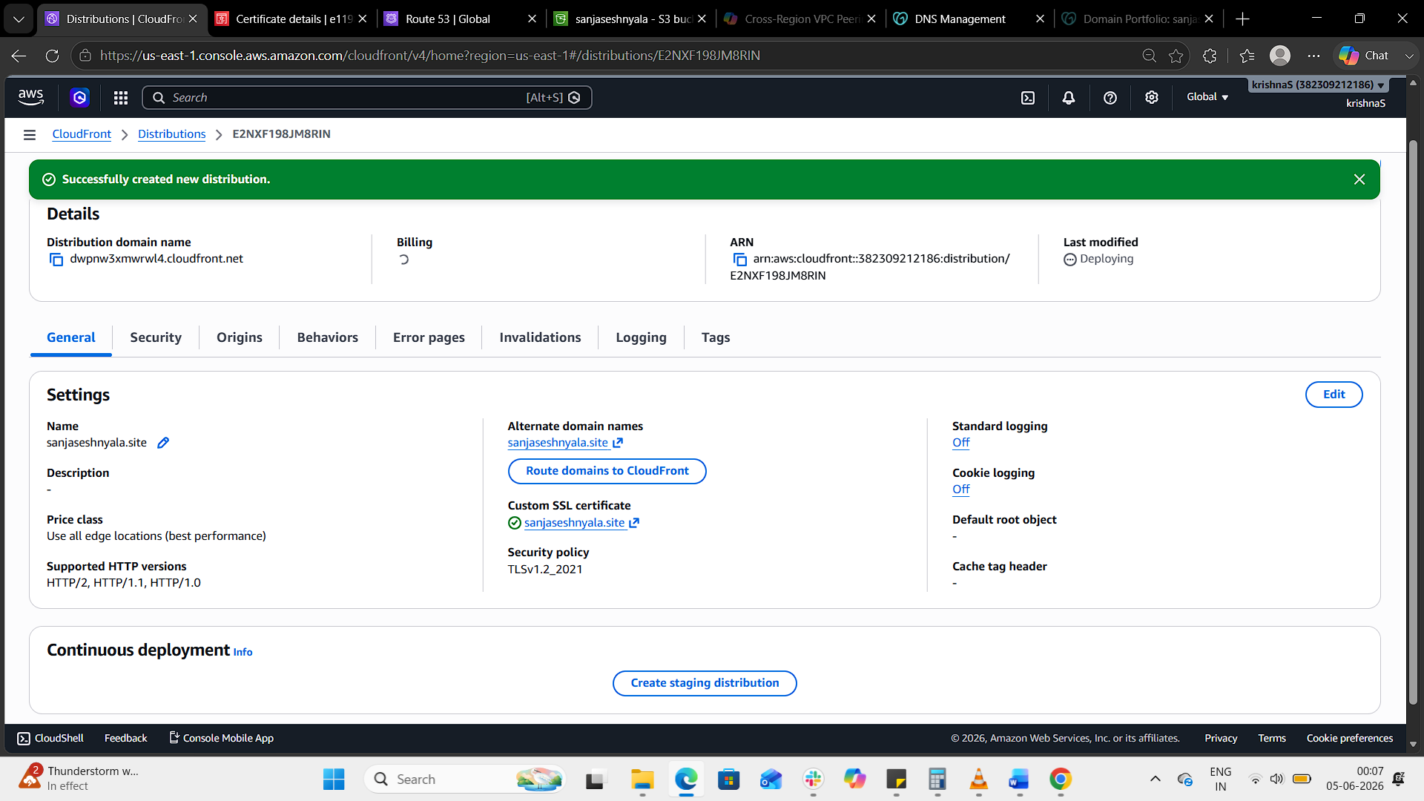
Step 3: Update DNS (GoDaddy → CloudFront)
In GoDaddy DNS management, update records:
  - CNAME for www → point to your CloudFront distribution domain (e.g., d123abcd.cloudfront.net).
  - A record for root domain (@) → use an Alias/ANAME pointing to CloudFront (if supported), or Route 53 for alias records.
Save changes.
Step 4: Test Your Site
- Open https://sanjaseshnyala.site.
- It should now load via CloudFront with HTTPS enabled.

- Create a Route 53 hosted zone and map the domain with the CDN.
- Update the index.html in the S3 bucket and ensure the updated file is accessible using the domain name.
- Share the domain name in Slack to test the connectivity.

